CS 255 System Design Document Template

System Overview
The DriverPass system is a cloud-based web application designed to help customers prepare for their driver's license examinations through online training, practice testing, and behind-the-wheel instruction. The system supports multiple user roles, including customers, secretaries, the IT officer, and the business owner. It provides scheduling, reporting, account management, online learning, and DMV update functionality.

UML Diagrams

UML Use Case Diagram
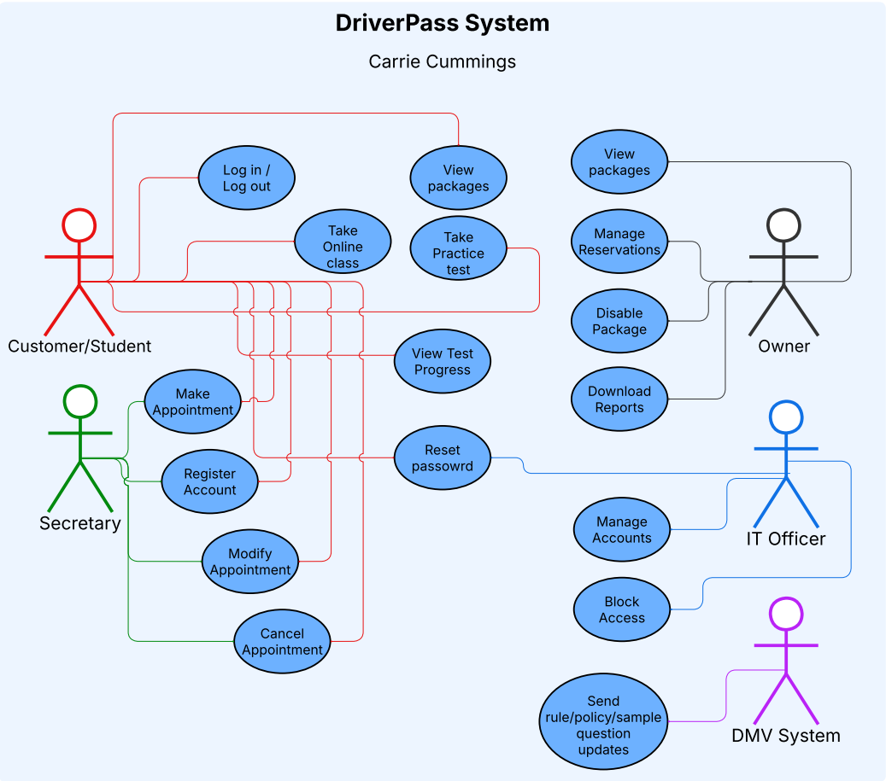

UML Activity Diagrams

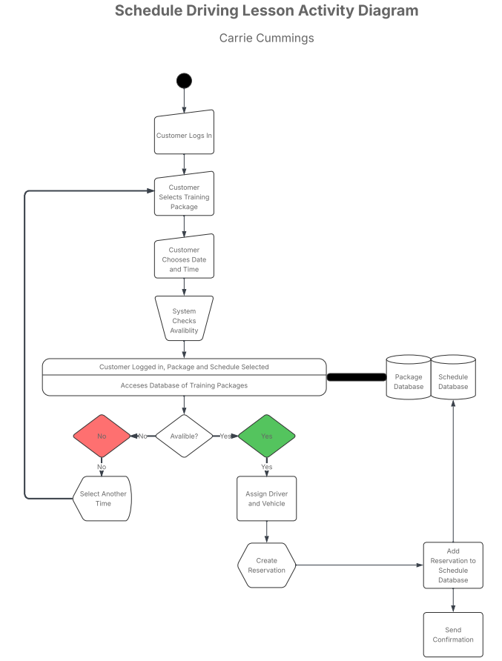

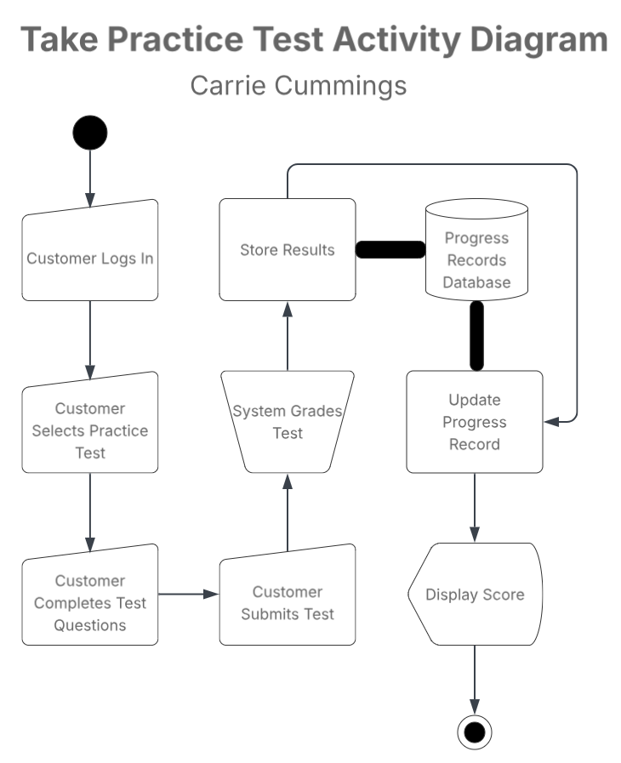

UML Sequence Diagram
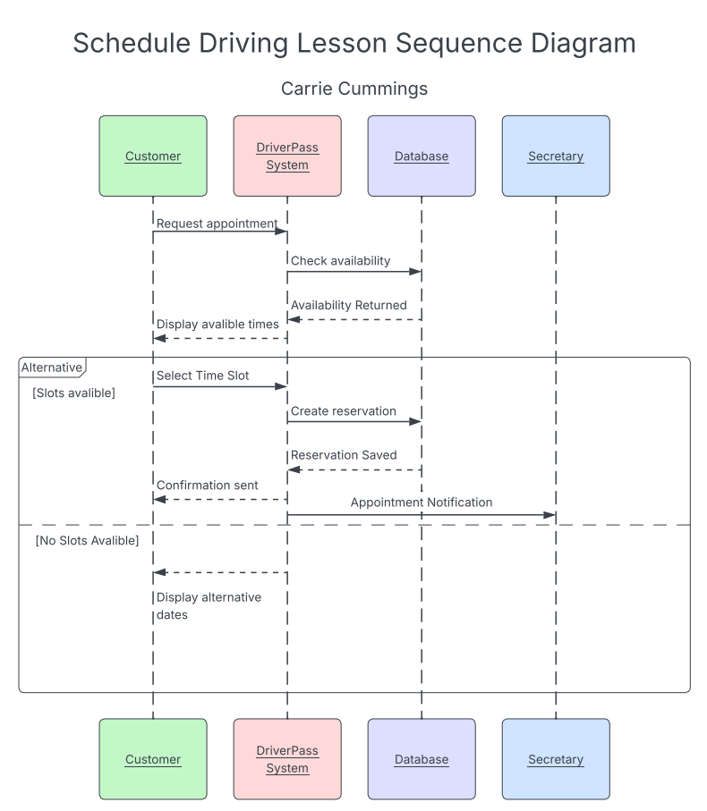

UML Class Diagram
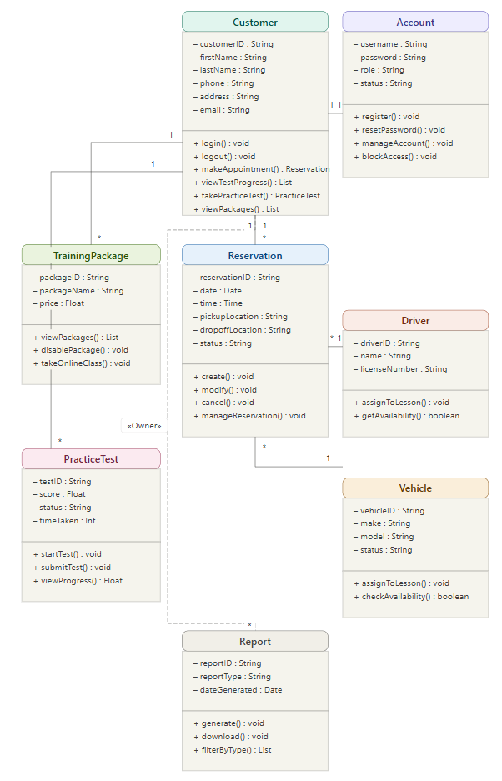

Technical Requirements
Hardware Requirements
- Cloud-hosted server environment
- Backup and recovery infrastructure
- Internet-connected desktops, laptops, tablets, and smartphones
- Administrative workstations for DriverPass staff
Software Requirements
- Modern web browsers (Chrome, Edge, Firefox, Safari)
- Relational database management system
- Secure payment processing service
- User authentication and account management software
Infrastructure Requirements
- Cloud hosting platform
- Encrypted communication between users and servers
- Automated database backups
- DMV update integration
- Reporting and activity tracking services
Security Requirements
- Role-based access control
- Secure login credentials
- Password reset functionality
- Account blocking capability
- Activity logging and auditing
- Protection of customer payment information

